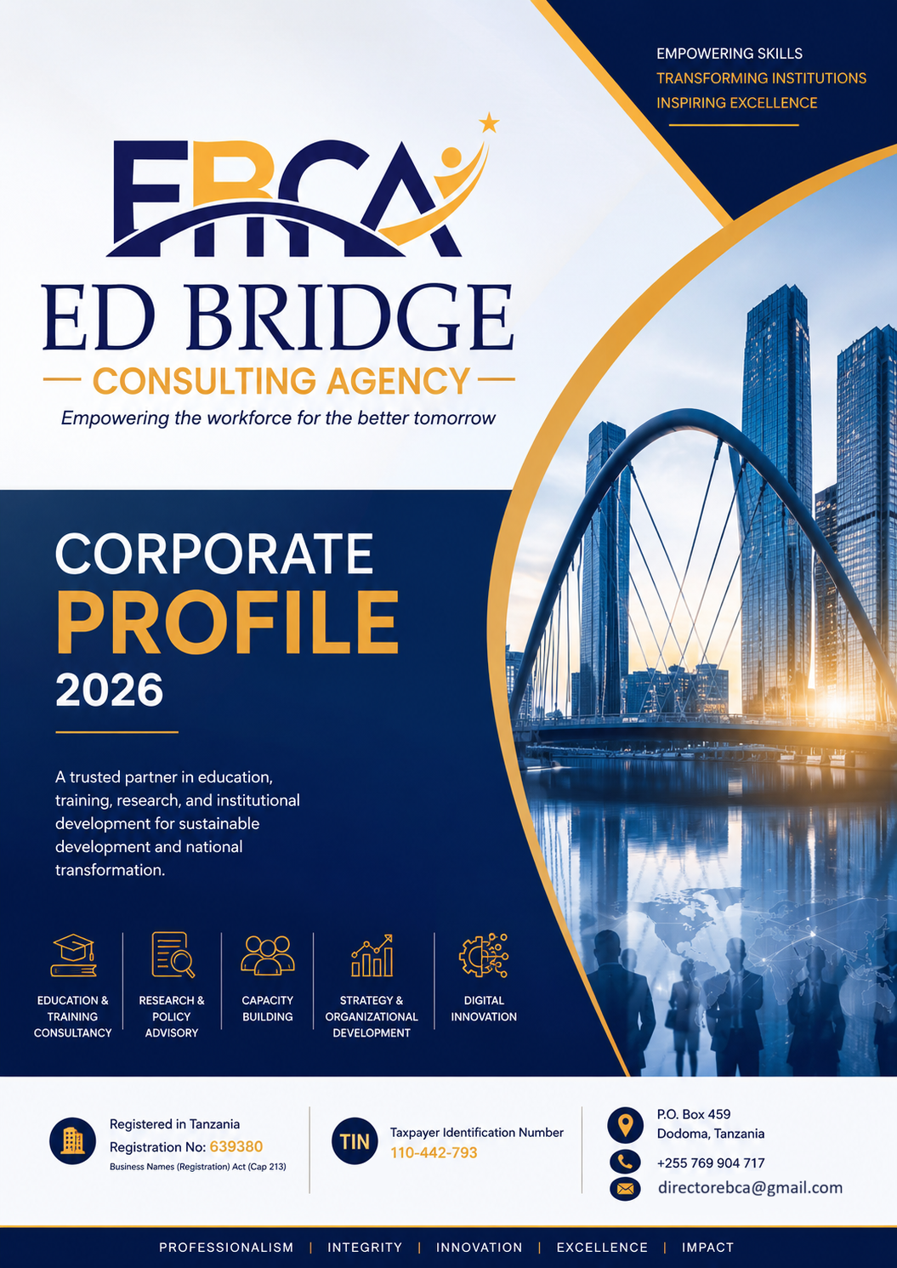

TABLE OF CONTENTS
TABLE OF CONTENTS 1
DIRECTOR GENERAL MESSAGE 2
OUR LEADERSHIP TEAM 3
Our Technical Team 4
Company Organization Structure 5
1.0 COMPANY OVERVIEW 6
2.0 COMPANY BACKGROUND 6
3.0 LEGAL STATUS 7
4.0 OUR VISION 7
5.0 OUR MISSION 7
6.0 OUR CORE VALUES 7
7.0 OUR CORPORATE PHILOSOPHY 8
8.0 STRATEGIC FOCUS 8
9.0 OUR SERVICE PORTFOLIO 9
9.1 Education and Training Consultancy 9
9.2 Curriculum Development and Review 9
9.3 Labour Market Research and Skills Gap Analysis 11
9.4 Research, Policy and Development Consultancy 12
9.5 Strategic Planning and Organizational Development 13
9.6 Monitoring, Evaluation, Accountability and Learning (MEAL) 14
9.7 Institutional Capacity Building 15
9.8 Digital Transformation and Educational Technology 16
9.9 Project Management Consultancy 17
10.0 CROSS-CUTTING THEMATIC AREAS 19
11.0 OUR WORKING METHODOLOGY 20
The EBCA Consultancy Framework 21
12.0 QUALITY ASSURANCE FRAMEWORK 22
13.0 OUR CLIENT ENGAGEMENT MODEL 22
14.0 TARGET CLIENTS 22
15.0 SECTORS WE SERVE 23
16.0 OUR COMPETITIVE ADVANTAGE 24
17.0 WHY CHOOSE ED BRIDGE CONSULTING AGENCY? 24
OUR VALUE PROPOSITION 25

DIRECTOR GENERAL MESSAGE
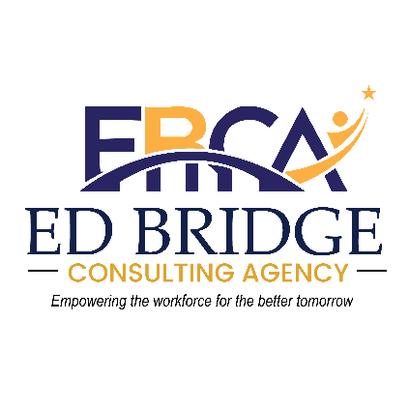
Welcome to ED Bridge Consulting Agency
It is my pleasure to welcome you to ED Bridge Consulting Agency (EBCA), a dynamic and forward-looking consultancy dedicated to empowering institutions, developing human capital, and delivering innovative solutions that promote sustainable socio-economic development.

At EBCA, we believe that quality education, institutional excellence, evidence-based decision-making, and continuous capacity development are the foundations of national transformation. Our commitment is to bridge the gap between policy, education, research, and labour market demands by providing practical consultancy services that create measurable impact.

The world is undergoing rapid technological, economic, and social transformation. Institutions today require innovative strategies, competent human resources, digital solutions, and evidence-based planning to remain competitive and responsive to changing environments. EBCA was established to support governments, educational institutions, development partners, private organizations, and communities in addressing these emerging challenges through professional consultancy, research, training, and institutional development services.

Our multidisciplinary team combines extensive experience in education, Technical and Vocational Education and Training (TVET), curriculum development, labour market analysis, organizational development, monitoring and evaluation, strategic planning, project management, and policy advisory. We pride ourselves on delivering customized solutions that are practical, innovative, and aligned with national priorities as well as international best practices.

As we continue to grow, our commitment remains unchanged to provide consultancy services that enhance institutional performance, strengthen workforce competencies, improve service delivery, and contribute to sustainable development.
We sincerely appreciate the confidence our clients and partners continue to place in us and look forward to building lasting partnerships that create value and transform lives.

Together, we bridge knowledge, innovation, and excellence.
Founder and Director General
ED Bridge Consulting Agency

OUR LEADERSHIP TEAM
ED Bridge Consulting Agency is guided by a team of highly qualified and experienced professionals who bring diverse expertise across multiple disciplines. Our leadership team is committed to excellence, innovation, and client-centered service delivery.

Director General

Is the Founder and Director General of ED Bridge Consulting Agency. He brings extensive experience in education management, TVET systems, curriculum development, and strategic leadership. With a passion for institutional transformation, he oversees the Agency's overall strategic direction and operations, ensuring that all consultancy services meet the highest standards of quality and impact.

Executive Director
The Supportive co-founder and Executive Director, responsible for driving the Agency's strategic initiatives and operational excellence. She brings a wealth of experience in organizational development, policy advisory, and programme management. Her leadership ensures that EBCA delivers client-centered solutions that are practical, innovative, and aligned with national and international development priorities.

Director of ICT

leads the Information and Communication Technology division at EBCA. With expertise in digital transformation, educational technology, and systems development, he drives the Agency's digital innovation agenda. His work focuses on integrating technology into education, developing e-learning platforms, and supporting institutions in their digital transformation journeys.

Assistant Director of ICT
Supports the ICT division, focusing on technical implementation, systems integration, and digital content development. He brings technical expertise in learning management systems, online assessment platforms, and knowledge management solutions. His role ensures that EBCA's digital solutions are robust, user-friendly, and tailored to client needs.

Director of Health Services and Supply
The Health Services and Supply division, specializing in health systems strengthening, medical supply chain management, and public health consultancy. With extensive experience in the health sector, he provides advisory services to government institutions, development partners, and healthcare organizations, contributing to improved health outcomes and service delivery.

Director of Data, Research and Consultancy
The Data, Research and Consultancy division, bringing advanced expertise in research methodology, data analytics, and evidence-based policy development. He oversees the design and implementation of research projects, baseline studies, impact evaluations, and labour market analyses. His leadership ensures that EBCA's consultancy services are grounded in rigorous research and credible data.

Quality Assurance Officer
The Quality Assurance Officer, responsible for upholding the highest standards of quality across all EBCA assignments. She ensures that every deliverable meets client expectations, regulatory requirements, and international best practices. Her role involves continuous monitoring, evaluation, and improvement of the Agency's quality management systems.

Technical Team
The Technical Team comprises Curriculum TVET Experts of Curriculum Development and the respective Fields from the National Council for Technical and Vocational Education and Training(NACTVET) and Vocational Education and Training (VET) including those from TVET institutions having the Qualification ranging from Bachelors Degree to Doctoral Ones including Professors.

Company Organization Structure
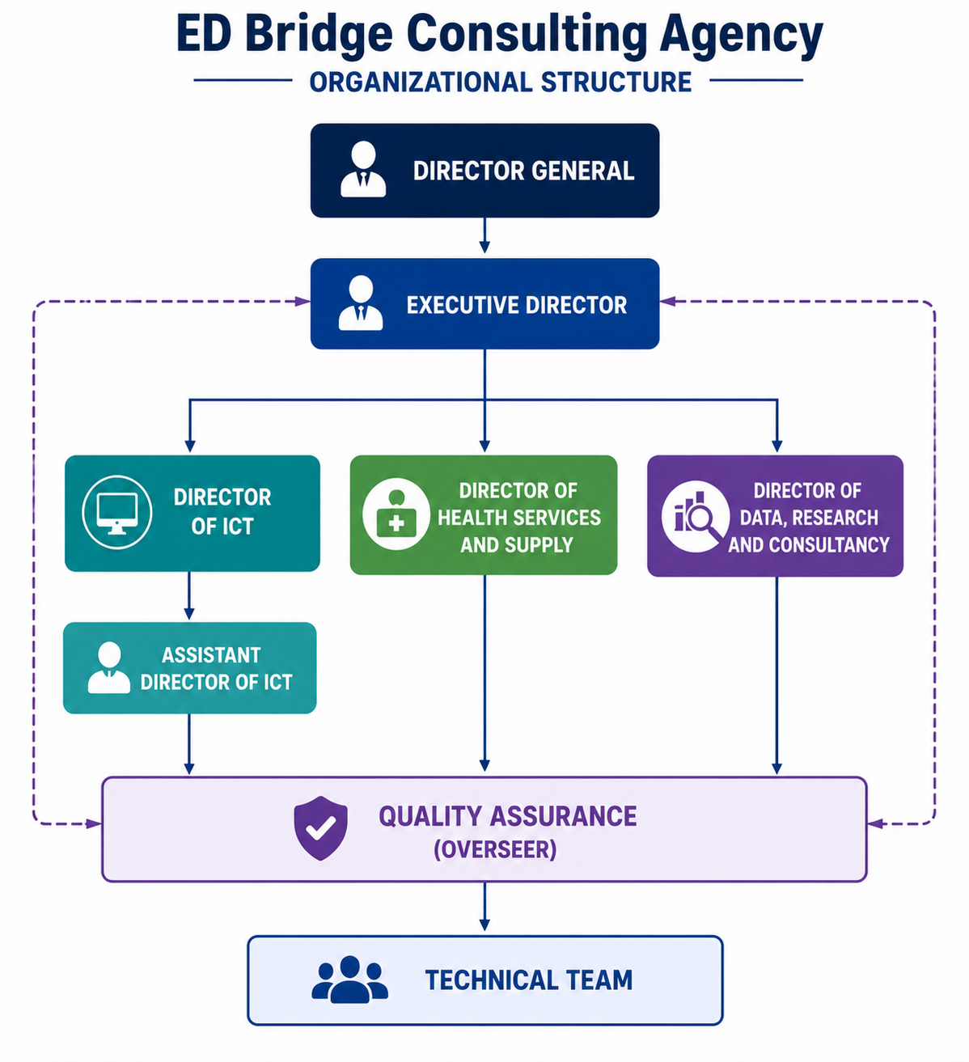

1.0 COMPANY OVERVIEW

ED Bridge Consulting Agency (EBCA) is a professional consultancy firm registered in the United Republic of Tanzania, providing high-quality consultancy, research, education, organizational development, and capacity-building services. The Agency was established to support public institutions, private organizations, development partners, educational institutions, and communities through innovative, evidence-based, and client-focused solutions that improve institutional effectiveness and promote sustainable development.

EBCA specializes in education and training consultancy, curriculum design and review, labour market studies, organizational capacity development, monitoring and evaluation, strategic planning, policy research, project management, and digital transformation. The Agency adopts a multidisciplinary approach that combines technical expertise, research excellence, and practical implementation experience to deliver solutions tailored to clients’ unique needs.
Recognizing the increasing demand for competent human resources and responsive institutions, EBCA is committed to developing innovative strategies that strengthen organizational performance, enhance workforce competencies, and promote inclusive socio-economic growth. Our services are guided by professionalism, integrity, innovation, and a commitment to excellence.

Through collaborative partnerships and stakeholder engagement, EBCA strives to become a trusted consultancy partner in Tanzania and across Africa by delivering practical solutions that create measurable and lasting impact.

2.0 COMPANY BACKGROUND

ED Bridge Consulting Agency was established with the vision of becoming a leading consultancy firm that bridges education, skills development, research, and institutional transformation. The Agency was founded in response to the growing demand for competent consultancy services to help organizations address emerging development challenges through innovative, evidence-based solutions.

The establishment of EBCA reflects a commitment to improving the quality of education, strengthening institutional capacity, enhancing workforce development, and supporting national development priorities. The Agency recognizes that sustainable development requires institutions equipped with competent human resources, effective systems, relevant policies, and strategic leadership.

Since its establishment, EBCA has positioned itself as a multidisciplinary consultancy serving government institutions, development partners, academic institutions, civil society organizations, private-sector organizations, and international agencies. The Agency combines research, policy analysis, strategic planning, capacity development, and technical advisory services to support organizational growth and improved service delivery.
EBCA is committed to promoting innovation, digital transformation, competency-based education, labour market responsiveness, and evidence-based decision-making. Through continuous learning and strategic partnerships, the Agency remains dedicated to delivering consultancy services that generate practical solutions and sustainable results.

3.0 LEGAL STATUS
ED Bridge Consulting Agency is a legally registered business operating in the United Republic of Tanzania. The Agency is registered under the Business Names (Registration) Act (Cap. 213) and is authorized to conduct consultancy and educational support services.

Table 1: Registration Details
Item | Details
Business Name | ED Bridge Consulting Agency
Registration Number | 639380
Registration Authority | Business Registrations and Licensing Agency (BRELA)
Registration Date | May 2026
Principal Office | Majengo, Dodoma City, Tanzania
Postal Address | P.O. Box 459, Dodoma
Telephone | +255 769 904 717
Email | chalewilly3@gmail.com
Business Activities | Educational Support Services, Consultancy, Research and Other Professional Services
Taxpayer Identification Number (TIN) | 110-442-793

4.0 OUR VISION
To become a leading consultancy agency in Africa and the entire World that transforms institutions and empowers individuals through innovative research, education, capacity development, and evidence-based solutions for sustainable development.

5.0 OUR MISSION
To provide high-quality consultancy, research, training, organizational development, and advisory services that strengthen institutions, develop human capital, promote innovation, and support inclusive socio-economic transformation.

6.0 OUR CORE VALUES
Collaboration
We believe lasting success is achieved through partnerships, teamwork, and stakeholder engagement.

Professionalism
We uphold the highest standards of competence, quality, and ethical conduct in every assignment.

Excellence
We pursue outstanding performance and continuously strive to exceed client expectations.

Client-Centred Service
We listen to our clients, understand their needs, and provide tailored solutions that create measurable value.

Innovation
We embrace creativity, technology, and new ideas to develop practical and sustainable solutions.

Integrity
We conduct our business with honesty, transparency, accountability, and fairness.

Sustainability
We promote solutions that contribute to long-term institutional resilience and national development.

7.0 OUR CORPORATE PHILOSOPHY

At ED Bridge Consulting Agency, we believe that institutions thrive when they are supported by competent people, evidence-based policies, innovative systems, and continuous learning. We view every consultancy assignment as an opportunity to create lasting value by translating knowledge into practical solutions that improve organizational performance and societal well-being.

Our philosophy is grounded in collaboration, innovation, and excellence. We work closely with clients to understand their unique contexts, identify opportunities for improvement, and co-create sustainable solutions that address current and future challenges. Through this approach, we bridge the gap between ideas and implementation, ensuring that every intervention delivers measurable impact.

We are committed to empowering institutions and individuals with the knowledge, skills, and strategic capabilities needed to succeed in an increasingly dynamic, technology-driven world.

8.0 STRATEGIC FOCUS

ED Bridge Consulting Agency (EBCA) is strategically positioned to support institutions in achieving sustainable development through innovative consultancy, research, capacity development, and organizational transformation. Our strategic focus is driven by the need to strengthen institutional performance, enhance workforce competencies, and promote evidence-based decision-making across public and private sectors.

As governments, educational institutions, industries, and development partners continue to respond to emerging socio-economic challenges, EBCA remains committed to delivering practical, client-centered solutions that address both current and future development needs.

Table 2: Our strategic priorities include
Priority | Description
a) | Promoting quality education and competency-based learning
b) | Strengthening Technical and Vocational Education and Training (TVET)
c) | Supporting institutional governance and organizational effectiveness
d) | Advancing labour market-responsive education and workforce development
e) | Enhancing research, innovation, and policy development
f) | Supporting digital transformation and technology integration
g) | Building resilient institutions through strategic planning and capacity development
h) | Promoting sustainable development aligned with national, regional, and global development agendas

9.0 OUR SERVICE PORTFOLIO
EBCA provides multidisciplinary consultancy services designed to improve organizational performance, strengthen human capital, and promote sustainable development. Our services are delivered using internationally recognized methodologies, evidence-based approaches, and best professional practices.

9.1 Education and Training Consultancy
Education remains the cornerstone of sustainable development. EBCA supports governments, educational institutions, regulatory authorities, and development partners in improving the quality of education through innovative consultancy services.

Table 3: Our services
Service | Description
Education Policy Analysis | Analyze existing and proposed education policies to assess their relevance, effectiveness, implementation challenges, and alignment with national development priorities and international best practices.
Education Sector Reviews | Conduct comprehensive reviews of the education sector to evaluate performance, identify systemic challenges, and provide evidence-based recommendations for policy reform and sector improvement.
Programme Accreditation Support | Provide technical assistance in preparing academic programmes for accreditation by ensuring compliance with national, regional, and international quality assurance standards and regulatory requirements.
Institutional Performance Assessment | Evaluate the effectiveness, efficiency, governance, academic quality, service delivery, and operational performance of educational institutions to support continuous improvement.
Academic Programme Development | Design, review, and revise academic programmes and curricula to ensure relevance, quality, competency-based learning, and alignment with labour market and industry needs.
Quality Assurance Systems | Develop and strengthen institutional quality-assurance frameworks, policies, procedures, and monitoring systems to promote continuous quality improvement across teaching, learning, research, and administration.
Education Management Consultancy | Provide expert advisory services on education leadership, governance, institutional management, organizational development, policy implementation, and change management.
School and Institutional Improvement Planning | Facilitate the development of evidence-based improvement plans that enhance institutional performance, teaching and learning, governance, infrastructure, and learner outcomes.
Training Needs Assessment | Identify organizational, institutional, and individual competency gaps to inform the design of targeted capacity-building programmes, professional development initiatives, and training interventions.
Education Strategic Planning | Support educational institutions and organizations in developing strategic plans that define their vision, mission, goals, priorities, implementation strategies, performance indicators, and monitoring frameworks.

9.2 Curriculum Development and Review
EBCA specializes in developing modern, labour market-responsive curricula that prepare learners with competencies required by today’s economy.

Table 4: Our curriculum services
Service | Description
Competency-Based Curriculum (CBC) Development | Design and develop competency-based curricula aligned with industry needs, national education policies, and international best practices.
Competency-Based Education and Training (CBET) Design | Develop CBET programmes that emphasize practical skills, workplace competence, and learner-centered training approaches.
Occupational Standards Development | Develop occupational standards that define the knowledge, skills, attitudes, and performance criteria required for specific occupations.
Qualification Framework Alignment | Align academic and professional qualifications with national and regional qualifications frameworks to ensure quality, comparability, and recognition.
Learning Outcomes Development | Formulate measurable learning outcomes that clearly define the competencies learners are expected to achieve.
Module Development | Develop competency-based learning modules with structured content, learning activities, and assessment strategies.
Course Specification Development | Prepare comprehensive course specifications including objectives, content, delivery methods, learning resources, and assessment requirements.
Assessment Tool Development | Design valid, reliable, and competency-based assessment instruments for formative and summative evaluation of learners.
Training Manuals Development | Produce practical training manuals that support effective teaching, learning, and workplace skills development.
Facilitators' Guides Development | Develop facilitators' guides that provide instructional methodologies, lesson plans, assessment guidance, and teaching strategies.
Learners' Manuals Development | Prepare learner-friendly manuals that facilitate self-directed learning and competency acquisition through structured activities and practical exercises.
Curriculum Review and Modernization | Review and update existing curricula to incorporate emerging technologies, labour market demands, policy changes, and innovative teaching approaches.
Curriculum Validation Workshops | Plan and facilitate stakeholder validation workshops to ensure curriculum relevance, quality, industry acceptance, and regulatory compliance before implementation.

Our curriculum development follows national regulatory requirements while incorporating international best practices.

9.3 Labour Market Research and Skills Gap Analysis
Understanding labour market dynamics is essential for developing relevant education programmes and workforce strategies.

Table 5: Our Labour Market Services
Service | Description
Labour Market Surveys | Conduct comprehensive surveys to analyze labour market trends, employment patterns, workforce demand and supply, wage dynamics, and emerging employment opportunities across sectors.
Skills Gap Assessments | Identify disparities between the skills of the current workforce and those required by employers, and provide evidence to inform workforce development and training interventions.
Skills Needs Assessments | Assess current and future workforce skill requirements across industries to support curriculum development, workforce planning, and human capital development strategies.
Occupational Analysis | Examine the roles, tasks, responsibilities, competencies, knowledge, skills, and qualifications required for specific occupations to support curriculum design, job profiling, and workforce planning.
DACUM Workshops (Developing A Curriculum) | Facilitate structured workshops with expert practitioners to identify occupational duties, tasks, knowledge, skills, tools, and work behaviours required for competency-based curriculum development and occupational standards.
Tracer Studies | Track graduates or programme beneficiaries to assess employment outcomes, career progression, further education, and the relevance of training programmes to labour market demands.
Graduate Employability Studies | Evaluate graduate employment outcomes, employability skills, career readiness, and factors influencing successful transition from education to the labour market.
Employer Satisfaction Surveys | Assess employers' perceptions of graduates' competencies, job performance, and workplace readiness to identify strengths and areas for improvement in education and training programmes.
Future Skills Forecasting | Analyze technological, economic, demographic, and industry trends to predict future workforce skill requirements and support long-term education, training, and labour market planning.
Industry Competitiveness Studies | Evaluate industry performance, productivity, workforce capabilities, innovation capacity, and competitiveness to identify opportunities for growth and strategic investment.
Human Capital Needs Assessments | Assess current and projected workforce requirements in terms of skills, competencies, staffing levels, and talent development to support organizational, sectoral, and national human capital planning.

Our research enables institutions to align education and training with emerging labour market demands.

9.4 Research, Policy and Development Consultancy
Evidence-based decision-making requires high-quality research and policy analysis.

Table 6: Our Research and Policy Services
Service | Description
Baseline Studies | Conduct comprehensive assessments to establish pre-intervention conditions, providing benchmark data for planning, monitoring, and evaluating projects and programmes.
End-line Evaluations | Assess project or programme outcomes upon completion by comparing end-line results with baseline data to determine effectiveness, impact, and achievement of objectives.
Policy Analysis | Analyze existing or proposed policies to assess their relevance, effectiveness, efficiency, feasibility, and potential socio-economic implications, while providing evidence-based recommendations.
Socio-economic Studies | Examine social and economic conditions, trends, and challenges affecting communities, institutions, or sectors to inform policy formulation and development planning.
Feasibility Studies | Evaluate the technical, financial, economic, environmental, and operational viability of proposed projects, programmes, or investments before implementation.
Impact Assessments | Measure the intended and unintended economic, social, environmental, or institutional effects of projects, programmes, or policies using rigorous evaluation methodologies.
Programme Evaluations | Assess the relevance, efficiency, effectiveness, sustainability, and overall performance of programmes to support accountability, learning, and informed decision-making.
Institutional Research | Conduct assessments to evaluate capacity, governance, performance, service delivery, and opportunities for strengthening.
Community Needs Assessments | Identify and prioritize the needs, challenges, resources, and opportunities within communities through participatory and evidence-based research approaches.
Public Policy Reviews | Review policies, strategies, and regulations to assess their implementation, effectiveness, coherence, and alignment with development goals.
Development Research | Undertake applied and policy-oriented research on economic, social, environmental, and governance issues to generate evidence for sustainable development interventions.
Strategic Policy Advisory Services | Provide governments, development partners, NGOs, and private-sector organizations with evidence-based strategic advice, policy recommendations, and technical support to support effective planning and decision-making.
Our multidisciplinary research team applies both qualitative and quantitative methodologies to produce credible, reliable, and actionable findings.

9.5 Strategic Planning and Organizational Development
Effective institutions require clear strategic direction and strong governance systems.

Table 7: Our Organizational Development Services
Service | Description
Strategic Plan Development | Facilitate the development of comprehensive strategic plans that define an organization's vision, mission, strategic objectives, priorities, implementation strategies, performance indicators, and monitoring and evaluation frameworks.
Business Plan Preparation | Prepare robust business plans that assess market opportunities, define business models, outline operational and financial strategies, evaluate risks, and support investment and growth decisions.
Corporate Plan Development | Develop corporate plans that translate strategic priorities into actionable programmes, resource allocation plans, performance targets, and implementation schedules to achieve organizational objectives.
Organizational Restructuring | Design and implement organizational restructuring initiatives to improve governance, operational efficiency, reporting structures, workforce alignment, and service delivery.
Change Management | Provide advisory and implementation support to help organizations manage change effectively through stakeholder engagement, communication strategies, capacity building, and transition planning.
Governance Reviews | Assess governance structures, policies, decision-making processes, accountability mechanisms, and compliance frameworks to strengthen organizational effectiveness and transparency.
Institutional Capacity Assessment | Evaluate institutional strengths, capacity gaps, systems, processes, human resources, and organizational capabilities to inform targeted capacity development interventions.
Risk Management Frameworks | Develop enterprise risk management frameworks, policies, and procedures to identify, assess, mitigate, monitor, and report strategic, operational, financial, and compliance risks.
Performance Management Systems | Design and implement performance management systems that define key performance indicators (KPIs), establish performance measurement frameworks, define appraisal processes, and implement continuous performance improvement mechanisms.
Organizational Culture Transformation | Support organizations in fostering positive workplace cultures by aligning values, leadership practices, employee behaviours, and organizational systems with strategic goals and desired performance outcomes.
Corporate Governance Advisory | Provide expert guidance on corporate governance principles, board effectiveness, regulatory compliance, ethical leadership, and governance best practices to strengthen organizational accountability and sustainability.

We help organizations become more responsive, efficient, accountable, and sustainable.

9.6 Monitoring, Evaluation, Accountability and Learning (MEAL)
EBCA supports organizations in measuring performance and demonstrating impact through comprehensive MEAL systems.

Our services include:
Service | Description
Monitoring and Evaluation (M&E) Framework Development | Design comprehensive monitoring and evaluation frameworks that define results chains, indicators, data sources, reporting mechanisms, roles, and learning processes to measure project and programme performance.
Indicator Development | Develop clear, measurable, and reliable performance indicators aligned with project objectives, outcomes, and impacts to facilitate effective monitoring and evaluation.
Theory of Change Development | Facilitate designing Theory of Change models that outline how interventions achieve outputs, outcomes, impacts, assumptions, and risks.
Logical Framework (Logframe) Development | Develop logical frameworks that define project goals, outcomes, outputs, activities, performance indicators, means of verification, assumptions, and risks to support effective project planning and management.
Results-Based Management (RBM) | Support organizations in adopting Results-Based Management approaches by establishing results frameworks, performance measurement systems, accountability mechanisms, and evidence-based decision-making processes.
Performance Monitoring Systems | Design and implement systems for tracking project and programme implementation, measuring progress against targets, and generating timely information for adaptive management and reporting.
Data Quality Assessments (DQA) | Assess the accuracy, completeness, reliability, timeliness, integrity, and consistency of monitoring and evaluation data to strengthen data quality and support informed decision-making.
Evaluation Studies | Conduct baseline, mid-term, end-line, process, outcome, and impact evaluations to assess the relevance, effectiveness, efficiency, sustainability, and impact of projects, programmes, and policies.
Learning Agenda Development | Develop organizational learning agendas to identify priority questions, evidence needs, knowledge management processes, and mechanisms for integrating lessons into policy and programme improvement.
Project Performance Reviews | Conduct systematic reviews of project implementation and performance to assess progress, identify challenges, document lessons learned, and recommend corrective actions for improved results.
Dashboard Development | Design interactive monitoring dashboards that visualize key performance indicators, project progress, and organizational performance to support real-time decision-making and reporting.
Impact Reporting | Prepare impact reports that showcase project achievements, outcomes, lessons learned, and contributions to goals for stakeholders and funders.
Our MEAL approaches promote evidence-based programming and continuous organizational learning.

9.7 Institutional Capacity Building
Organizations perform better when their people possess the appropriate competencies.

Table 8: Our Capacity Building Programmes Cover
Area | Description
Leadership Development | Build leadership competencies in strategic thinking, decision-making, team leadership, emotional intelligence, change management, and organizational performance to develop effective leaders at all levels.
Executive Coaching | Provide personalized coaching for senior executives and managers to strengthen leadership effectiveness, strategic decision-making, communication, performance, and professional growth.
Management Training | Enhance managerial capabilities in planning, organizing, leading, controlling, problem-solving, delegation, and performance management to improve organizational effectiveness.
Project Management | Develop competencies in project planning, implementation, scheduling, budgeting, risk management, monitoring, evaluation, and project closure using recognized project management methodologies and best practices.
Financial Management | Strengthen skills in budgeting, financial planning, accounting, financial reporting, internal controls, resource mobilization, and financial decision-making to promote sound financial stewardship.
Procurement Management | Build capacity in procurement planning, tendering, contract management, supplier evaluation, regulatory compliance, ethical procurement, and value-for-money principles.
Human Resource Management | Equip participants with practical knowledge and skills in recruitment, performance management, employee relations, talent management, training and development, compensation, and labour law compliance.
Digital Skills | Develop digital competencies in the effective use of productivity software, digital collaboration tools, data management, cybersecurity awareness, digital transformation, and emerging technologies in the workplace.
Communication Skills | Enhance written, verbal, interpersonal, presentation, negotiation, and public speaking skills to improve workplace communication and stakeholder engagement.
Research Skills | Build capacity in research design, literature review, data collection, quantitative and qualitative analysis, academic writing, research ethics, and dissemination of research findings.
Monitoring and Evaluation (M&E) | Develop practical skills in results-based management, indicator development, monitoring frameworks, data collection, data quality assurance, evaluation methodologies, and performance reporting.
Report Writing | Strengthen professional writing skills for technical reports, policy briefs, research reports, proposals, and organizational documents with an emphasis on clarity, structure, and evidence-based communication.
Customer Service Excellence | Equip participants with skills to deliver high-quality customer service through effective communication, relationship management, complaint resolution, service standards, and customer satisfaction improvement.
Governance Training | Strengthen knowledge and skills in corporate governance, public sector governance, board effectiveness, accountability, ethics, compliance, risk management, and institutional leadership.

Our training programmes combine theory with practical application to ensure measurable improvements in performance.

9.8 Digital Transformation and Educational Technology
Technology continues to reshape education, governance, and organizational performance.

Table 9: Our Digital Services
Service | Description
E-learning Development | Design and develop engaging, interactive, and learner-centred e-learning courses using instructional design principles, multimedia content, and industry-standard authoring tools to support flexible learning.
Learning Management Systems (LMS) | Provide end-to-end LMS solutions, including system selection, customization, implementation, integration, user training, administration, and ongoing technical support to enhance learning delivery and management.
Digital Curriculum Development | Design and transform curricula into digital learning experiences that incorporate competency-based approaches, interactive resources, multimedia content, and technology-enhanced instructional strategies.
Educational Technology Integration | Support educational institutions in integrating digital technologies into teaching, learning, assessment, and administration to improve learner engagement, instructional effectiveness, and institutional performance.
Online Assessment Systems | Design and implement secure, reliable, and scalable online assessment solutions for formative and summative evaluations, including automated grading, performance analytics, and academic integrity measures.
Digital Content Development | Develop high-quality digital learning resources, including e-books, interactive modules, videos, animations, simulations, infographics, and other multimedia materials to enhance learning outcomes.
Virtual Training Platforms | Design, deploy, and manage virtual training environments that support live online instruction, webinars, collaborative learning, learner engagement, and performance tracking.
AI Integration in Education | Advise on and implement artificial intelligence solutions to enhance teaching, learning, assessment, student support, personalized learning, predictive analytics, and institutional decision-making while promoting responsible AI use.
Digital Transformation Strategies | Develop comprehensive digital transformation strategies that guide educational institutions in adopting innovative technologies, strengthening digital capabilities, improving operational efficiency, and enhancing learning experiences.
Knowledge Management Systems | Design and implement knowledge management systems that facilitate the creation, organization, sharing, retrieval, and preservation of institutional knowledge, promoting collaboration, innovation, and informed decision-making.

Our digital solutions enhance efficiency, accessibility, and institutional competitiveness.

9.9 Project Management Consultancy
EBCA provides comprehensive support throughout the project life cycle.

Table 10: Our Project Management Services
Service | Description
Project Design | Design evidence-based projects by identifying needs, defining objectives, developing intervention strategies, engaging stakeholders, and establishing implementation and results frameworks aligned with organizational and donor priorities.
Proposal Development | Prepare high-quality project proposals that include problem analysis, objectives, methodology, implementation plans, logical frameworks, monitoring and evaluation plans, budgets, and sustainability strategies tailored to donor requirements.
Project Planning | Develop comprehensive project implementation plans that define activities, timelines, resource requirements, responsibilities, risk mitigation measures, and performance indicators to ensure effective project execution.
Budget Preparation | Prepare detailed and realistic project budgets, including cost estimates, resource allocation, cash flow projections, budget narratives, and financial plans that comply with donor and organizational requirements.
Implementation Support | Provide technical assistance throughout project implementation, including project coordination, stakeholder engagement, quality assurance, problem-solving, and adaptive management to achieve project objectives.
Project Monitoring | Establish and implement monitoring systems to track project progress, measure performance against indicators, identify implementation challenges, and provide timely information for evidence-based decision-making.
Risk Assessment | Identify, analyze, and evaluate strategic, operational, financial, environmental, and implementation risks, and develop practical mitigation and contingency plans to enhance project success.
Project Evaluation | Conduct mid-term, final, and impact evaluations to assess project relevance, effectiveness, efficiency, sustainability, and impact, while generating lessons learned and recommendations for future programming.
Donor Reporting | Prepare accurate, timely, and evidence-based technical and financial reports that communicate project progress, results, challenges, lessons learned, and compliance with donor reporting requirements.
Sustainability Planning | Develop sustainability strategies that promote the long-term continuation of project benefits through capacity building, institutional ownership, resource mobilization, partnerships, and exit planning.
Project Close-out | Support the systematic closure of projects by completing administrative and financial requirements, documenting lessons learned, conducting final reporting, transferring assets and responsibilities, and ensuring compliance with contractual obligations.
We ensure projects are delivered on time, within budget, and aligned with stakeholder expectations.

10.0 CROSS-CUTTING THEMATIC AREAS
EBCA integrates cross-cutting priorities into all consultancy assignments to ensure inclusive and sustainable outcomes.
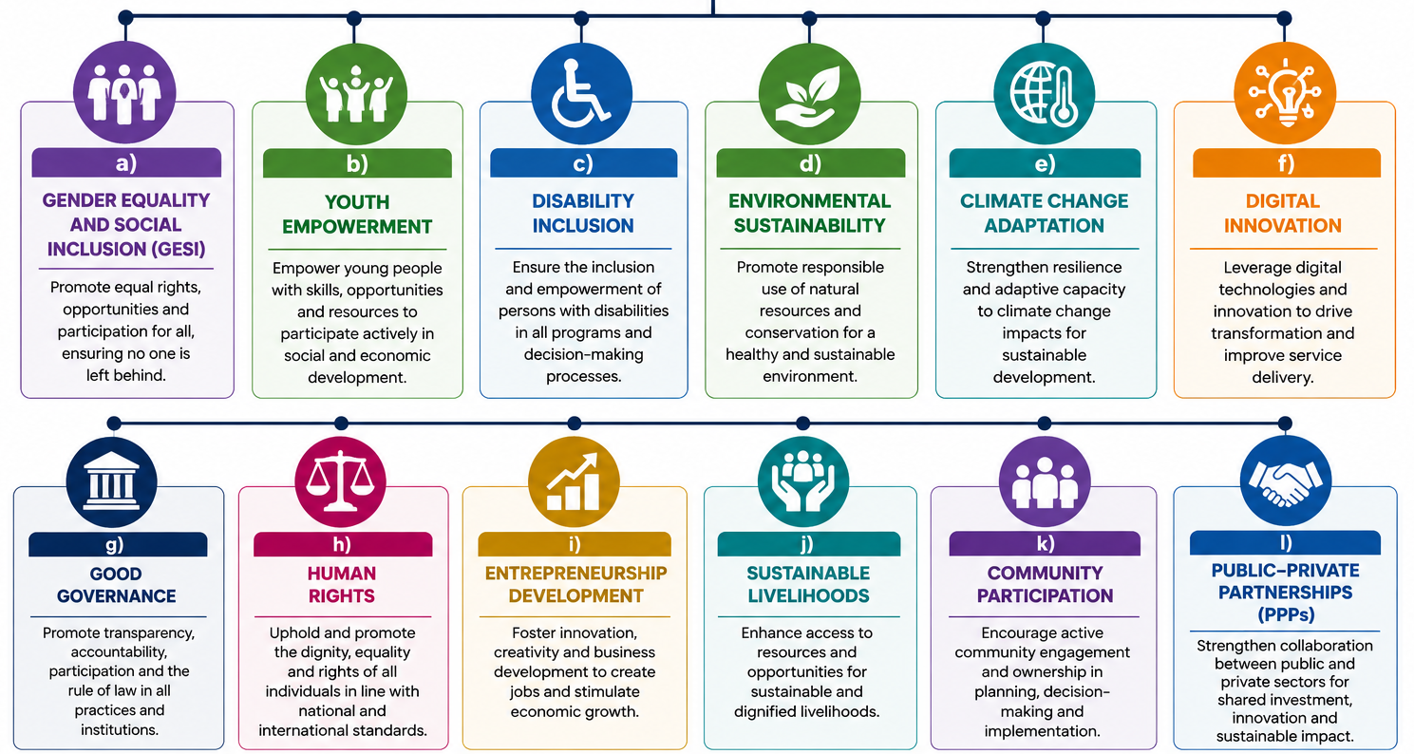

These themes are mainstreamed throughout our research, training, policy development, and institutional support services.

11.0 OUR WORKING METHODOLOGY
At ED Bridge Consulting Agency (EBCA), we believe that sustainable solutions are built on rigorous research, stakeholder collaboration, innovation, and continuous improvement. Every assignment is implemented through a structured consultancy framework that ensures quality, accountability, and measurable impact.

Our methodology combines international best practices with local expertise to deliver customized solutions that respond to the unique needs of our clients.

The EBCA Consultancy Framework
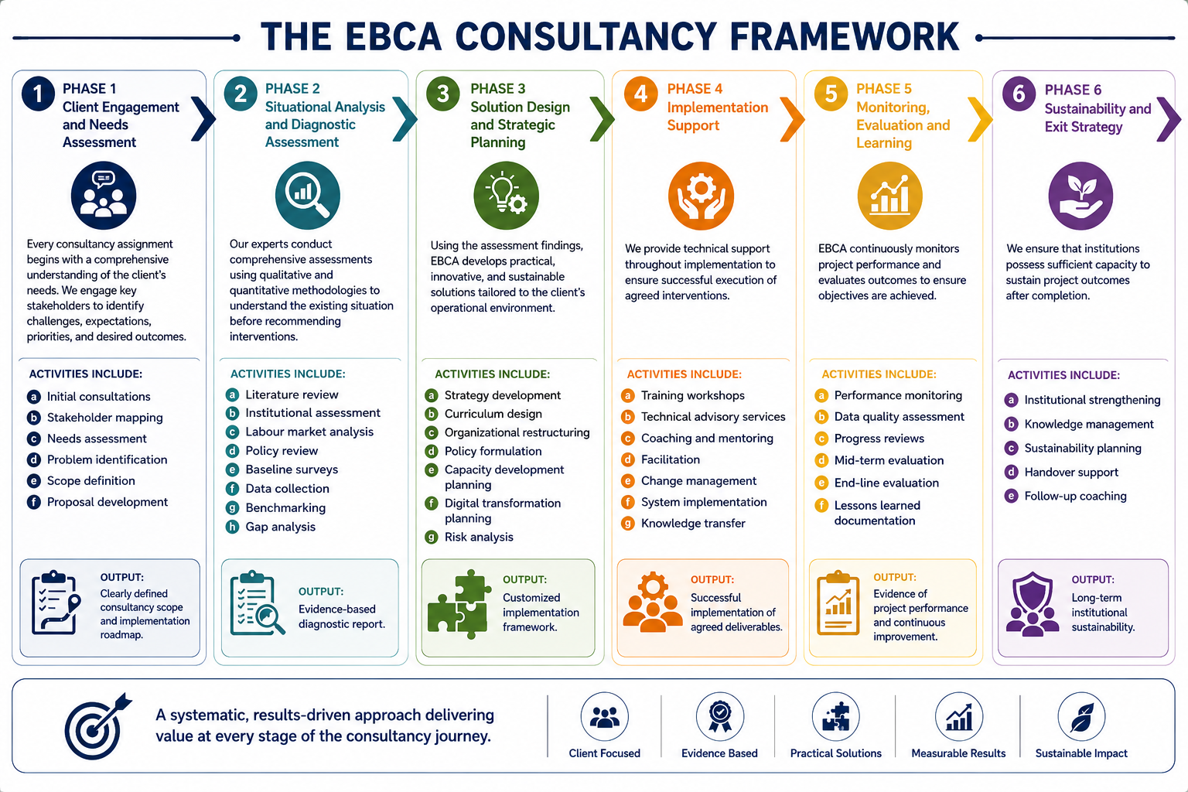

12.0 QUALITY ASSURANCE FRAMEWORK
Quality is embedded in every stage of our consultancy assignments. EBCA applies internationally recognized quality management principles to ensure consistency, reliability, and client satisfaction.

Table 11: Our Quality Assurance Framework is built upon the following pillars
Pillar | Description
Professional Excellence | Assignments are executed by highly qualified consultants with extensive professional experience.
Evidence-Based Practice | Recommendations are grounded in credible research, reliable data, and internationally accepted methodologies.
Client Participation | Clients actively participate throughout project implementation to ensure ownership and relevance.
Ethical Standards | We uphold integrity, confidentiality, accountability, and professional ethics in all engagements.
Continuous Improvement | Lessons learned from previous assignments are integrated into future projects to enhance service quality.
Compliance | Our consultancy services comply with national legislation, regulatory requirements, and international development standards.

13.0 OUR CLIENT ENGAGEMENT MODEL
At EBCA, clients are regarded as strategic partners rather than service recipients.

Our engagement model emphasizes:
- Partnership
- Transparency
- Open communication
- Mutual accountability
- Timely reporting
- Shared decision-making
- Long-term relationships

This collaborative approach enables us to develop practical solutions that create lasting institutional impact.

14.0 TARGET CLIENTS
Our consultancy services are designed to meet the needs of a diverse range of organizations across Tanzania, Africa, and beyond.
Our clients include:

Government Institutions
- Ministries
- Government Departments
- Executive Agencies
- Local Government Authorities
- Regulatory Authorities
- Public Institutions
Development Partners
- United Nations Agencies
- International NGOs
- Bilateral Development Agencies
- Multilateral Organizations
- International Foundations
- Donor-funded Programmes
Education and Training Institutions
- Universities
- Colleges
- TVET Institutions
- Schools
- Teacher Training Colleges
- Research Institutions
Private Sector
- Corporate Organizations
- Industries
- Small and Medium Enterprises (SMEs)
- Business Associations
- Professional Bodies
Civil Society Organizations
- Non-Governmental Organizations
- Community-Based Organizations
- Faith-Based Organizations
- Professional Associations
International Organizations
- Regional Institutions
- International Consultancy Firms
- Global Education Networks
- International Research Organizations

15.0 SECTORS WE SERVE
EBCA possesses multidisciplinary expertise across numerous sectors.
Sector | Sector
Education | Technical and Vocational Education and Training (TVET)
Higher Education | Public Administration
Local Government | Health Systems
Agriculture | Environment and Climate Change
Youth Development | Gender and Social Inclusion
Entrepreneurship | Digital Economy
Information and Communication Technology | Governance
Labour and Employment | Tourism and Hospitality
Water and Sanitation | Community Development
Financial Inclusion | Social Protection

16.0 OUR COMPETITIVE ADVANTAGE
EBCA differentiates itself through a unique combination of technical expertise, innovation, professionalism, and client-centered service delivery.
Our strengths include:

Multidisciplinary Expertise
Our consultants possess extensive experience across education, research, governance, institutional development, policy analysis, monitoring and evaluation, and organizational transformation.
Evidence-Based Solutions
Every recommendation is supported by rigorous research, credible data, and stakeholder consultation.
Client-Centered Approach
We develop customized solutions tailored to each client’s operational context and strategic objectives.
Innovation
We integrate digital technologies, artificial intelligence, data analytics, and emerging best practices into our consultancy services.
Professional Integrity
We uphold the highest standards of ethics, confidentiality, accountability, and transparency.
Sustainable Impact
Our interventions focus not only on solving immediate challenges but also on strengthening institutional systems for long-term success.

17.0 WHY CHOOSE ED BRIDGE CONSULTING AGENCY?
Organizations choose EBCA because we consistently deliver value through professionalism, innovation, and measurable results.

Table 12: We Offer
Service Attribute | Benefit
Highly qualified multidisciplinary consultants | Ensures access to diverse technical expertise, enabling comprehensive, well-rounded solutions to complex and multi-sectoral challenges.
Client-focused solutions | Guarantees that services are tailored to client needs, priorities, and context, resulting in practical and relevant outcomes.
International consultancy standards | Ensures high-quality outputs aligned with global best practices, improving credibility, reliability, and acceptance by development partners and stakeholders.
Innovative and practical approaches | Delivers creative yet implementable solutions that enhance efficiency, effectiveness, and real-world applicability.
Evidence-based recommendations | Supports decision-making with rigorous data, analysis, and research, increasing accuracy, accountability, and impact of interventions.
Timely delivery of assignments | Ensures projects are completed within agreed timelines, improving planning, coordination, and stakeholder satisfaction.
Strong stakeholder engagement | Promotes inclusive participation, ownership, and collaboration, leading to better acceptance and sustainability of outcomes.
Excellent quality assurance systems | Ensures consistency, accuracy, and high standards in deliverables through structured review and quality control mechanisms.
Competitive consultancy services | Provides cost-effective solutions without compromising quality, offering strong value for money to clients.
Commitment to sustainable development | Ensures that interventions contribute to long-term social, economic, and environmental sustainability outcomes.
Extensive knowledge of Tanzania's policy and regulatory environment | Enhances compliance, contextual relevance, and effectiveness of solutions within national legal and institutional frameworks.
Experience working with diverse institutions across multiple sectors | Enables adaptability and cross-sectoral learning, improving the ability to handle varied client needs and complex assignments.

At EBCA, we do not simply provide consultancy we build partnerships that transform institutions, strengthen human capital, and create sustainable development outcomes.

OUR VALUE PROPOSITION
Empowering Institutions. Developing People. Delivering Sustainable Solutions.
Through research, innovation, strategic partnerships, and professional excellence, ED Bridge Consulting Agency is committed to becoming a trusted consultancy partner to governments, development partners, educational institutions, private organizations, and communities seeking transformative, lasting solutions.

Together, we bridge knowledge, innovation, and impact.

